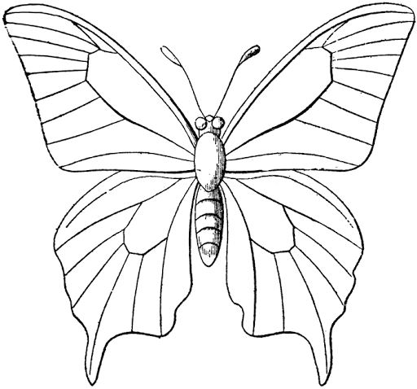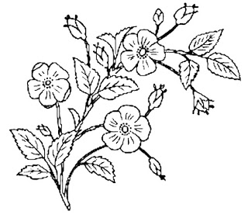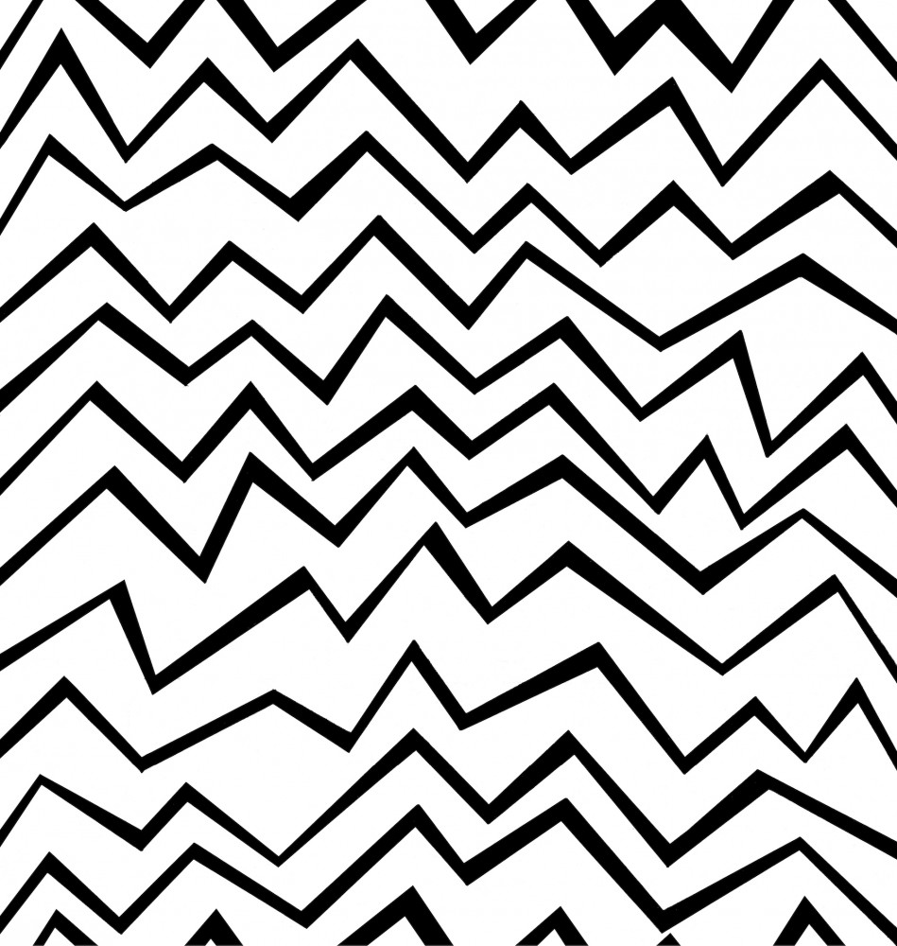Dragon Club Snowdrop Vase Designs!

If you liked learning about the Victorians and how much they loved Snowdrops, then try this design for your Snowdrop Vase!

Victorians loved fancy patterns of butterflies and flowers and birds all over their things, especially in colours like pale blue, pink, and black.

Print Out, Colour in, Cut Out and Glue onto an empty toilet roll tube!   
If you don’t have a printer, then these squares are 10cm X 12cm. Try cutting out of lined paper to get stripes to colour in, or draw your own design! You could even cut pictures out of a magazine and stick them on to decorate your vase (or glue other things on, like glitter or dried pasta shells!) It’s YOUR vase so do whatever you want!

If you like a fun modern style then try these dynamic zigzags for your vase! Make sure you use lots of colours so that the lines POP.